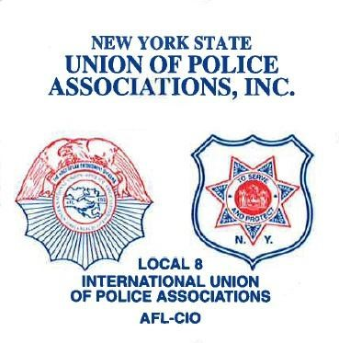Montgomery County Deputy Sheriffs Police Benevolent Association Inc.

**President Vice President Secretary/Treasurer**

Thomas Flickinger Luke Paine Justin Smith

March 28, 2022

Jeffrey T. Smith

Committee to Elect Jeff Smith for Montgomery County Sheriff

33 Park Street

Fonda, New York 12068

RE: Endorsement for Election to Sheriff of Montgomery County

Dear Sheriff Smith:

On behalf of the Montgomery County Deputy Sheriff’s Police Benevolent Association, Inc. (PBA), I am pleased to convey the endorsement of this organization for your re-election to Sheriff of Montgomery County.

The PBA’s endorsement is a result of your background and support for the law enforcement community as well as your recognition of police officers and deputy sheriffs as dedicated and hard-working public employees who go out each and every day to serve the public at great personal risk and sacrifice. You have created a Sheriff’s Office that the public can trust and we know that you will continue to work hard for the citizens of Montgomery County. We are proud to call you our Sheriff and we are happy to come to work every day knowing we have a hard-working Sheriff who is out for the best for his employees. The PBA will be urging its membership, their families and their friends who reside in Montgomery County to support your re-election.

It is our hope and expectation that the voters of Montgomery County will acknowledge your commitment and service by voting for you to be re-elected to the position of Sheriff on Election Day.

Wishing you success.

Sincerely,

Thomas Flickinger,

President